YouTube’s Adpocalypse

Your group will have 15 minutes for this activity. One group member should volunteer to copy this document, share the copy with their group (so that anyone can edit), and read Proposal 1 and Proposal 2 out loud to the group. (In the absence of a volunteer, nominate whoever's last name is alphabetically first!) The group should collectively then answer the questions below, replacing each TODO with the group's collective thoughts.

# Proposals

## Proposal 1

YouTube uses an algorithm to detect extremist commentary and subsequently demonetize the video–a process wherein content creators are denied paid advertisements in their video, thus denying them revenue from YouTube's platform. Sometimes, the algorithm cannot distinguish between extremist commentary and content that simply covers sensitive or controversial issues.

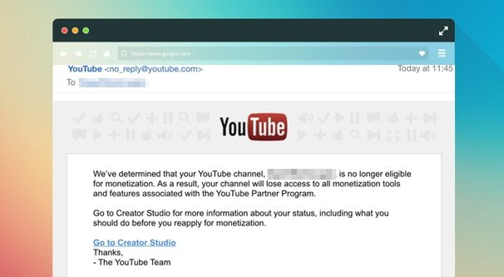

## Proposal 2

However, a designer at YouTube believes that there needs to be a different approach to content regulation. Their proposal is that the algorithm should decide which videos are demonetized based strictly on popularity in terms of expected views. More specifically, any video that falls below a certain threshold of views should be demonetized.

# 

## **Five Rights and Opportunities for a Democratic Public Sphere**

# **Rights**. As citizens of a democracy, we have rights to basic liberties, such as liberties of expression and association. The right to expressive liberty is important not only for the freedom of the individual, so that he or she is not censored, but also for democracy itself. It enables citizens to bring their ideas into conversation with one another, and to criticize and hold accountable those who exercise power.

# **The opportunity for Expression**. Not only should we be free of censorship but we should have fair opportunity to participate in public discussion. It shouldn't be the case that because someone is wealthier or more powerful that they should have more opportunity to participate.

# **Access**. Each person should have good and equal access to quality and reliable information on public matters. That is, IF we make the effort, we should be able to acquire this information. Effective participation in decision making on public matters requires being informed.

# **Diversity**. Each person should have good and equal chances to hear a wide range of views. We need access to competing views in order to have a more informed and reasoned position.

# **Communicative power**. Citizens should have good and equal chances to explore interests and ideas in association with others, and through these associations, to develop new concerns that challenge the mainstream view.

# 

# Questions

1. Which form of content regulation, Proposal 1 or Proposal 2, do you feel is better? Why?
   1. Proposal 1 because the fact that it provides greater access for those who don’t already have a large viewer base to get their content out into the world.
2. Which form of content regulation, Proposal 1 or Proposal 2, do you think best preserves or promotes the [five rights and opportunities necessary for a democratic public sphere](https://cs50.harvard.edu/college/2020/fall/labs/10/lecture/#five-rights-and-opportunities-for-a-democratic-public-sphere)?
   1. Which proposal best preserves or promotes Rights? Why?
      1. Both proposals don’t promote rights very well, because Proposal 1 restricts those whose channels may talk about sensitive topics, and Proposal 2 restricts those whose channels may not be very popular.
   2. Which proposal best preserves or promotes Opportunity for Expression? Why?
      1. Proposal 1 best preserves or promotes Opportunity for Expression, as all publishers of video content will have a similar chance of relaying their content to audiences of similar size, regardless of the number of views or users subscribed to their channel. Proposal 2 would be more discriminatory towards less viewed publishers by intentionally reducing the publicity of their videos, compared to proposal 1, which does not discriminate on this line.
   3. Which proposal best preserves or promotes Access? Why?
      1. Proposal 1 better promotes Access because proposal 2 does not provide “good and equal” access to quality and reliable information on public matters as the proposal may lead to discrimination based on number of viewers.
   4. Which proposal best preserves or promotes Diversity? Why?
      1. Proposal 1 better promotes diversity of socioeconomic class because Proposal 2 rewards creators who already have other popular videos and are more likely to have more funds.
   5. Which proposal best preserves or promotes Communicative Power? Why?
      1. While both proposals somewhat infringe on Communicative Power, Proposal 1 best preserves it of the two because it allows all creators to be monetized provided that their content is not “extremist.”